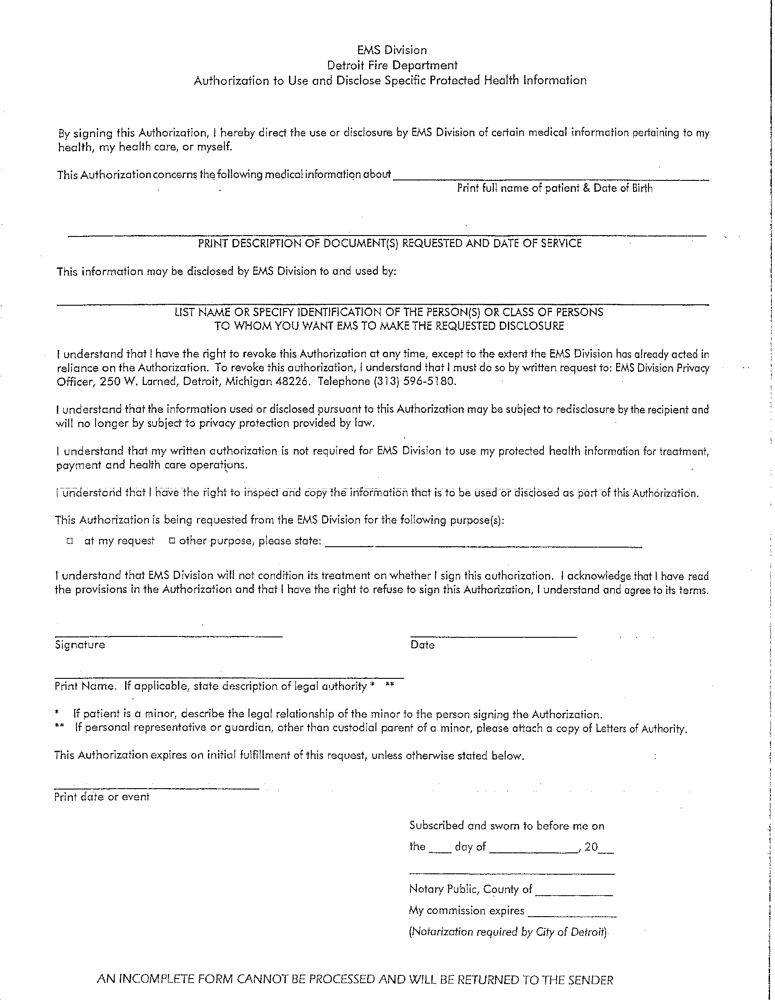
Batman DOB: 01/01/1979

Secret Location Under Office Building Gotham, NJ

Axiom Requisition Copy Service
2869 Jolly Road
Okemos, MI 48864
PH: (877) 886-5090
records@axiomcopy.com
FROM 01/01/1979 TO PRESENT: Any and all MEDICAL RECORDS, including but not limited to patient history form(s), reports, etc. pertaining to Batman SSN: xxx-xx-5555, DOB: 01/01/1979.
X
Litigation

